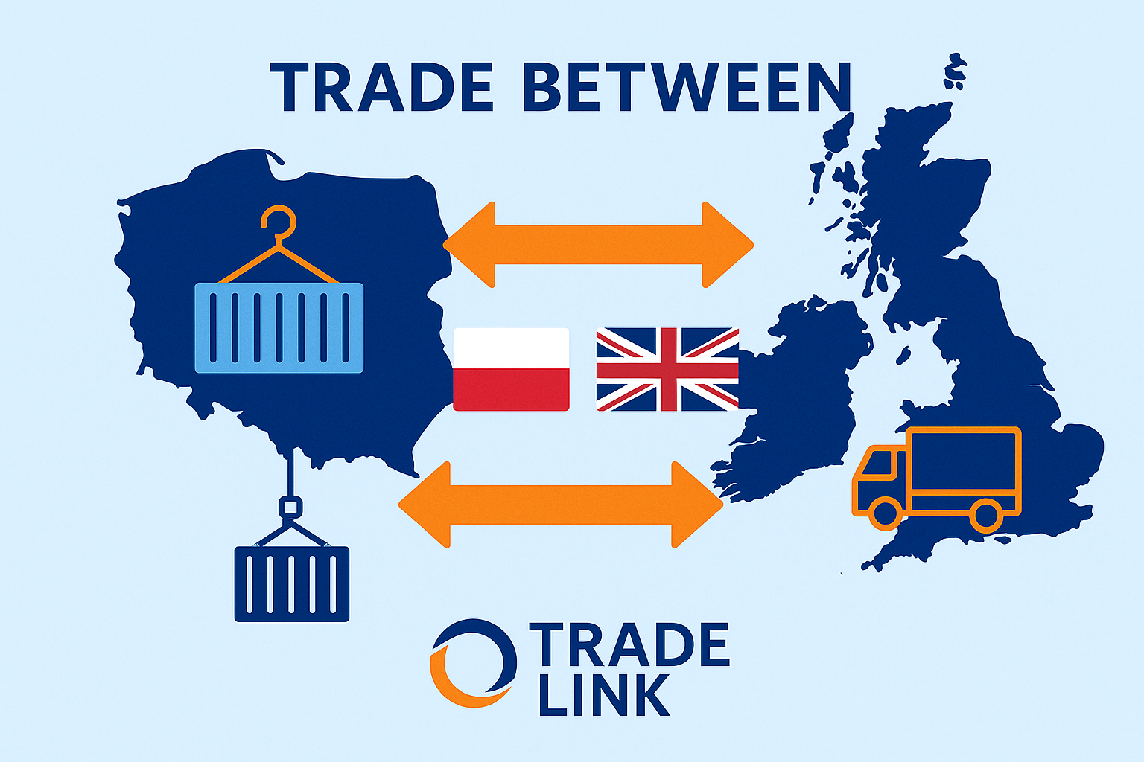

**Trade Between Poland and the UK: Opportunities, Challenges, and How Trade Link Makes It Simple**

***Connecting two growing economies with expertise, logistics, and trust.***

Trade between **Poland and the United Kingdom** continues to grow despite economic shifts, regulatory changes, and post-Brexit complexities. Both markets offer huge potential — Poland as one of the fastest-developing EU economies, and the UK as a hub for innovation, services, and import demand.

But tapping into this opportunity requires more than ambition — it requires insight, connections, and smooth logistics. That’s exactly where **Trade Link** steps in.

**🇵🇱🇬🇧 The Power of UK–Poland Trade**

Trade between Poland and the UK is valued in **billions of pounds annually**. Poland remains one of the UK’s top trading partners, especially for sectors like:

* **Automotive parts and machinery**
* **Food and agricultural products**
* **Furniture and home goods**
* **Chemicals and industrial materials**
* **Transport and logistics services**

The UK exports everything from pharmaceuticals to IT services, while Poland supplies high-quality manufactured goods, agricultural produce, and skilled workforce capabilities.

This exchange is vital — it drives innovation, keeps supply chains efficient, and fuels thousands of business partnerships on both sides.

**⚙️ The Post-Brexit Challenge**

While trade opportunities have expanded, **post-Brexit regulations** introduced new hurdles for importers and exporters:

* Customs declarations and duties
* Compliance with UK and EU standards
* Delays caused by documentation errors
* Complexities in VAT and border checks

These challenges can slow business growth and create costly inefficiencies — unless you have the right partner.

**🚀 How Trade Link Simplifies UK–Poland Trade**

**Trade Link** was built to make international trade easier, faster, and more reliable. We bridge the gap between Polish and British businesses with three core services:

**1️⃣ Market Research & Entry**

We help you understand your target market — from demand trends and competitor analysis to pricing and regulations. Whether you’re a UK company entering Poland or a Polish exporter expanding into the UK, our **local insight** sets you up for success.

**2️⃣ Trader Connections**

Trade Link connects **verified partners, distributors, and suppliers** across both markets. Our B2B matchmaking ensures you work with trusted contacts who share your business goals.

**3️⃣ Transport & Customs Clearance**

From **T1 documents** to **import/export declarations**, **IPAFFS**, **EUR.1 certificates**, and **ENS filings**, Trade Link handles all the details so your goods move seamlessly. Our logistics experts ensure fast, compliant cross-border shipping every time.

**💡 Why Businesses Choose Trade Link**

✅ One partner for market entry, trade facilitation, and logistics  
✅ Deep expertise in both UK and Polish regulations  
✅ Transparent, reliable communication  
✅ End-to-end support — from research to delivery

We don’t just move goods — we **move opportunities.**

**🌍 Ready to Grow Across Borders?**

Whether you’re an exporter in Warsaw or an importer in Manchester, Trade Link gives you the insight, partners, and logistics support you need to trade confidently between Poland and the UK.

**Trade Link — Connecting Markets. Moving Opportunities.**  
📩 Contact us today to discuss your next trade venture.